

CAPSTONE PROJECT REPORT
Report 5 – Software Test Documentation
SuperMarketBot: Autonomous Supermarket Assistance & In-Store Advertising Robot System

– Ho Chi Minh, September 2026 –
Table of Contents
I. Record of Changes 3
II. Testing Documentation 4
1. Scope of Testing 4
2. Test Strategy 4
2.1 Testing Types 4
2.2 Test Levels 4
2.3 Supporting Tools 4
3. Test Plan 4
3.1 Human Resources 4
3.2 Test Environment 5
3.3 Test Milestones 5
4. Test Cases 5
5. Test Reports 5

I. Record of Changes
Date | A* M, D | In charge | Change Description
15/07/2026 | A | Nguyễn Quang Huy | Initial draft of Software Test Documentation: Scope of Testing, Test Strategy, and Human Resources allocation.
10/08/2026 | A | Nguyễn Quang Huy, Nguyễn Anh Hùng, Lê Trọng Hiếu | Formulated Unit & Integration Test suites for Backend REST APIs, Realtime MQTT/SignalR, and AI Microservice.
01/09/2026 | A | Trần Nguyễn Nhật Khoa, Nguyễn Hoàng Trường Duy | Designed System & UI Test Cases for Web Admin Portal, Staff App, Customer App, and Robot Android App.
15/09/2026 | M | Nguyễn Quang Huy | Executed full test cycles, aggregated test execution metrics, verified defect resolutions, and finalized Report 5.
*A - Added M - Modified D - Deleted

II. Testing Documentation

1. Scope of Testing
Features and Functions to be Tested:
Subsystem 1: Backend Core Services (SuperMarketBot-BE .NET 10 Clean Architecture):
- • User Authentication & Authorization: JWT access token generation, refresh token rotation, BCrypt password hashing, and role-based endpoint authorization (Admin, Brand, Staff, Member).
- • Contactless Face Recognition Check-in: Ingesting customer front-camera frames, delegating to FastAPI AI microservice, mapping 128-D face embeddings to Member records, and loading loyalty profiles.
- • Product Catalog & Inventory Management: Product and category CRUD, health tags, and bulk Excel import with duplicate SKU/barcode detection and error reporting.
- • Dijkstra Waypoint Navigation: Graph representation of 3.0m x 3.0m supermarket arena (8 Navigation Nodes, 11 bidirectional Edges), shortest path computation, unreachable node handling, and floor isolation.
- • Real-time Robot Mission Dispatch & Telemetry: Publishing MQTT waypoint commands (robot/{robotCode}/command), ingesting robot telemetry updates, and broadcasting live states over SignalR RobotHub.
Subsystem 2: Computer Vision & AI Microservice (ai-service FastAPI + OpenCV + ONNX):
- • Face Engine: High-speed face detection via OpenCV YuNet (<25ms latency, <60MB RAM) and facial feature embedding extraction via SFace ONNX runtime.
- • 2-Stage Shelf Vision: Stage 1 YOLOv8 product bounding box detection, empty slot classification, and ArUco marker identification (#1 to #6); Stage 2 MobileNetV3 Re-ID 1024-D feature extraction with Cosine Similarity matching against calibrated reference crops.
- • Shelf Boundary Guard: Geometric coordinate bounding relative to detected ArUco marker (tag_x - 25 to tag_x + tag_w * 8.8) to eliminate floor reflections and background noise.
- • Shelf Stock Density Calculation: Computing slot stock percentage and triggering low-stock alerts when capacity falls below predefined thresholds.
- • AI-Assisted Smart Shopping & Meal Planner: Google Gemini API integration for natural-language recipe generation, structured ingredient extraction, and budget-constrained product substitution.
Subsystem 3: Web Admin & Brand Advertising Portal (SuperMarketBot-FE React 19 + Vite):
- • Administrative Management: Account role assignment, product catalog management, and interactive shelf slot visual mapping across 6 physical shelves.
- • Brand Advertising Lifecycle: Ad package selection, 3-tier campaign creation (Zone-targeted, Shelf-targeted, Route-targeted), campaign review, and automated Brand Wallet balance deduction.
- • Live Robot Fleet Monitoring: Real-time 2D/3D visualization powered by Three.js, rendering live robot coordinates, battery level, speed, and status (Idle, Moving, Interacting, Charging).
- • In-Store Advertising Analytics: Real-time impression tracking, campaign logs, and financial transaction history.
- • Responsive Web Experience: Cross-browser responsive design built with TailwindCSS and secure route guarding.
Non-Functional Requirements to be Tested:
- • Security: JWT token verification, role-based endpoint protection (Admin, Brand, Staff, Member), SQL injection prevention via EF Core parameterization, and secure credential storage in Expo SecureStore.
- • Usability: Clean, clutter-free digital supermarket map on Staff App (path lines hidden per user feedback), intuitive touch navigation on Robot display, and responsive web admin portal.
- • Performance & Response Time: AI face recognition inference < 1.0s, AI shelf scanning inference < 250ms, REST API response time < 500ms, and zero payload timeout over ngrok/LTE tunnels.
- • Real-Time Latency & Reliability: MQTT command transmission latency < 100ms, SignalR telemetry update latency < 80ms, and resilient reconnection on Azure SQL Serverless wakeups.
Test Levels Applied:
• Unit Test: Testing individual C# classes and methods in isolation within SmartMarketBot.Tests (50 unit tests) and Python AI algorithms (YuNet, SFace, YOLO, MobileNetV3).
• Integration Test: Validating interactions between REST APIs, SignalR Hubs, MQTT Broker, ROS2 navigation bridge, and Azure SQL Server transactions.
• System Test: Testing end-to-end user journeys across Web Admin Portal, Staff Mobile/Web App, Customer Android App, and Robot Android App.
• Acceptance Test: Validating complete business operational scenarios with stakeholders (smart shopping, autonomous shelf patrol, and targeted robotic advertising).
Constraints and Assumptions:
- • Testing Environment: Testing is conducted in a controlled supermarket arena (3.0m x 3.0m arena with 6 shelves, cash register, and charging dock) rather than an open active commercial store.
- • Test Data Integrity: Dedicated test accounts, seeded products (50+ items), calibrated shelf slots, and mock brand wallets with pre-funded test balances are utilized.
- • Hardware Availability: Robot hardware tests are conducted using ROS2 robot nodes; software simulators and mock bridges are used when robot hardware is offline for charging.

2. Test Strategy

2.1 Testing Types
Functional Testing
- • Objective: Verify that all business features across Backend, Web Admin, Staff App, Customer Mobile App, and Robot App perform according to functional specifications.
- • Technique: Black-box and gray-box testing, boundary value analysis, and equivalence partitioning.
- • Completion Criteria: 100% of planned functional test cases executed; all critical and high-priority defects resolved.
API & Communication Testing
- • Objective: Validate REST API endpoints, SignalR hubs, MQTT broker contracts, request/response formats, HTTP status codes, and database transaction integrity.
- • Technique: Automated execution using xUnit, Postman test collections, and MQTTX client simulation.
- • Completion Criteria: All endpoints return expected HTTP status codes (200, 201, 400, 401, 404), schema-compliant JSON payloads, and maintain zero data corruption.
UI & Usability Testing
- • Objective: Ensure user interfaces on Web Admin, Staff App, Customer Mobile App, and Robot Touchscreen display correctly and provide intuitive navigation across devices.
- • Technique: Manual testing across web browsers (Chrome, Edge) and physical Android test devices (Android 13/14 phones and tablets).
- • Completion Criteria: Responsive layouts render properly, touch interactions respond accurately, and digital store maps display cleanly without visual clutter.

2.2 Test Levels
Type of Tests | Test Level
Type of Tests | Unit | Integration | System | Acceptance
Functional Testing | X | X | X | X
API & Contract Testing | X | X | X
UI & Usability Testing |  |  | X | X
Realtime & IoT Testing (MQTT/SignalR) | X | X | X | X
AI Computer Vision & Face Verification | X | X | X | X

2.3 Supporting Tools
Purpose | Tool | Vendor / In-house | Version
Backend Unit Testing | xUnit & FluentAssertions | .NET Foundation / Open-source | v2.9.2 / v7.0.0
API & Endpoint Testing | Postman & REST Client | Postman Inc. | v11.x
Web Admin UI Testing | Google Chrome DevTools | Google LLC | v131+ (Chromium)
Mobile Android App Testing | Android Studio & ADB | Google LLC | Ladybug 2024.2+
IoT Messaging Testing | MQTTX Client | EMQ Technologies | v1.9+
Computer Vision / Face AI | OpenCV & ONNX Runtime | Open Source / Microsoft | v4.10 / v1.19

3. Test Plan

3.1 Human Resources
Worker / Doer | Role | Specific Responsibilities / Comments
Nguyễn Quang Huy | Leader
Nguyễn Anh Hùng | Member
Lê Trọng Hiếu | Member
Trần Nguyễn Nhật Khoa | Member
Nguyễn Hoàng Trường Duy | Member

3.2 Test Environment

Purpose | Environment / Tool | Provider | Version
Backend Runtime | .NET 10 SDK & Kestrel Server | Microsoft | 10.0.310
AI Microservice | Python 3.11 & FastAPI / Uvicorn, YOLO, OpenCV Engine | Python Software Foundation | Python 3.14.3, FastAPI 0.141.1, Uvicorn 0.52.4, Ultralytics 8.4.26, OpenCV 5.0.0
Relational Database | Microsoft Azure SQL Server / Local Express | Microsoft | v12.0 (Serverless Tier)
Frontend Web Runtime | Node.js & Vite (React 19) | Open-source | Node v20.14.0, Vite 8.0.12, React 19.2.6
Mobile App Runtime | Expo SDK & React Native | Expo / Meta | Expo 57.0.21, (ReactNative 0.86.3)
IoT Messaging Broker | Eclipse Mosquitto (MQTT) | Eclipse Foundation | v2.0.18 (TCP Port 1883)
Operating Systems | Windows 11 Pro & Ubuntu 26.04 LTS | Microsoft / Canonical | Win11 23H2 / Ubuntu 26.04
Test Mobile Devices | Android Physical Hardware (Phones & Robot Display) | Xiaomi / Samsung | Android 13 / 14

3.3 Test Milestones

Milestone Task | Start Date | End Date
Milestone 1: Create Test Plan & Strategy Document | 15/09/2026 | 22/09/2026
Milestone 2: Develop Unit Tests (Backend xUnit & AI Microservice) | 13/09/2026 | 17/09/2026
Milestone 3: Develop Integration Tests (API Endpoints, MQTT, SignalR, DB) | 16/09/2026 | 18/09/2026
Milestone 4: Develop System & UI Tests (Web Admin & Staff Web Portal) | 09/09/2026 | 10/09/2026
Milestone 5: Develop Mobile & Robot End-to-End Tests (Customer & Robot Apps) | 04/09/2026 | 05/09/2026
Milestone 6: Execute Full Regression Testing & Resolve Defect Backlog | 06/09/2026 | 12/09/2026
Milestone 7: Finalize Software Test Documentation, Metrics & Sign-off | 10/09/2026 | 15/09/2026

4. Test Cases
View Unit Test Cases (BE & AI Microservice): Report5_Unit Test.xlsx
View Other Test Cases (IT, ST, AT & Defect Log): Report5_Test Report.xlsx
The test suite is partitioned into four rigorous testing levels spanning all five active repositories in the Supermarket Bot ecosystem. All test cases are completely defined with unique identifiers, prerequisites, test steps, expected results, and actual outcomes. A high-level summary of the test distribution is presented in Table 6 below:
Test Level | Target Repository / Component | Test ID Range | Case Count
Unit Testing (BE) | SuperMarketBot-BE (src/SmartMarketBot.Tests) | UT_BE_001 – UT_BE_050 | 50 Test Cases
Unit Testing (AI) | SuperMarketBot-BE (ai-service/ Face & Shelf Vision) | UT_AI_001 – UT_AI_012 | 12 Test Cases
Integration Testing (IT) | BE REST APIs, SignalR Hubs, MQTT Broker, Azure SQL | IT_AUTH_001 – IT_IMP_001 | 15 Test Cases
System Testing (ST) | Web Admin, Staff App, Customer Mobile, Robot Android | ST_ADM_001 – ST_ROB_004 | 17 Test Cases
Acceptance Testing (AT) | End-to-End Supermarket Operational Scenarios | AT_SCE_001 – AT_SCE_003 | 3 Scenarios
TOTAL SUITE | Comprehensive Ecosystem Coverage (5 Repos) | All Test Levels | 97 Test Cases
4.1 Unit Test Cases (from Report5_Unit Test.xlsx)
The automated Unit Test suite covers 50 test methods in the .NET 10 Backend test project (SmartMarketBot.Tests) and 12 test scenarios in the Python FastAPI AI Microservice. The official test workbook captures are embedded in Figures 1, 2, and 3 below:
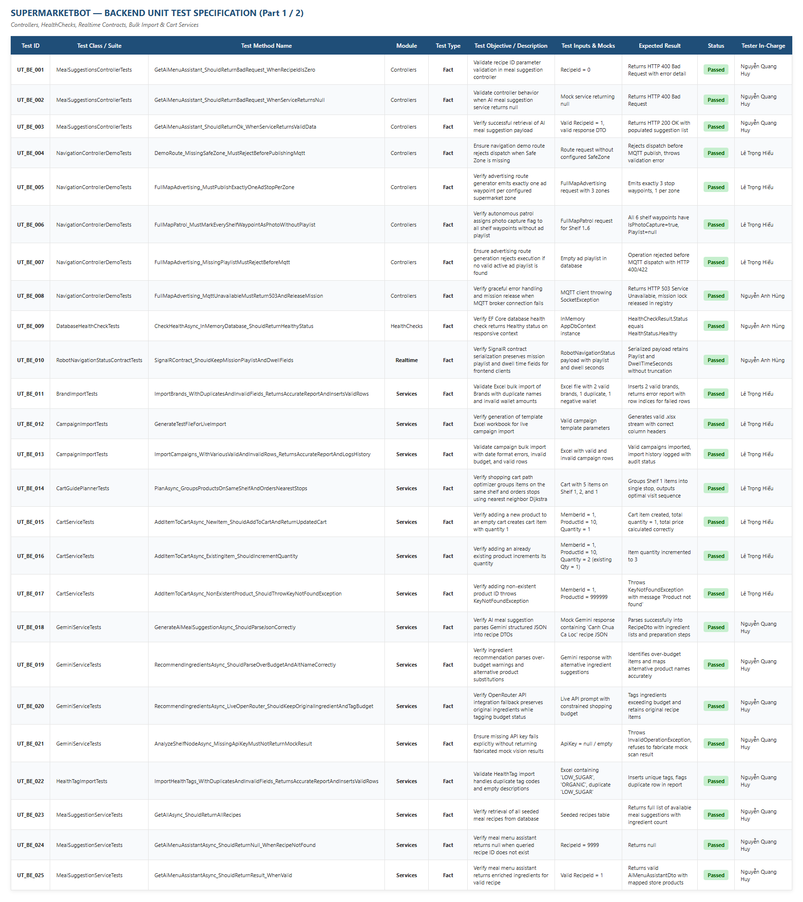
Figure 1: Unit Test Cases Specification for Backend Services (Part 1 / 2 – Controllers, HealthChecks, Realtime, Cart, Import)
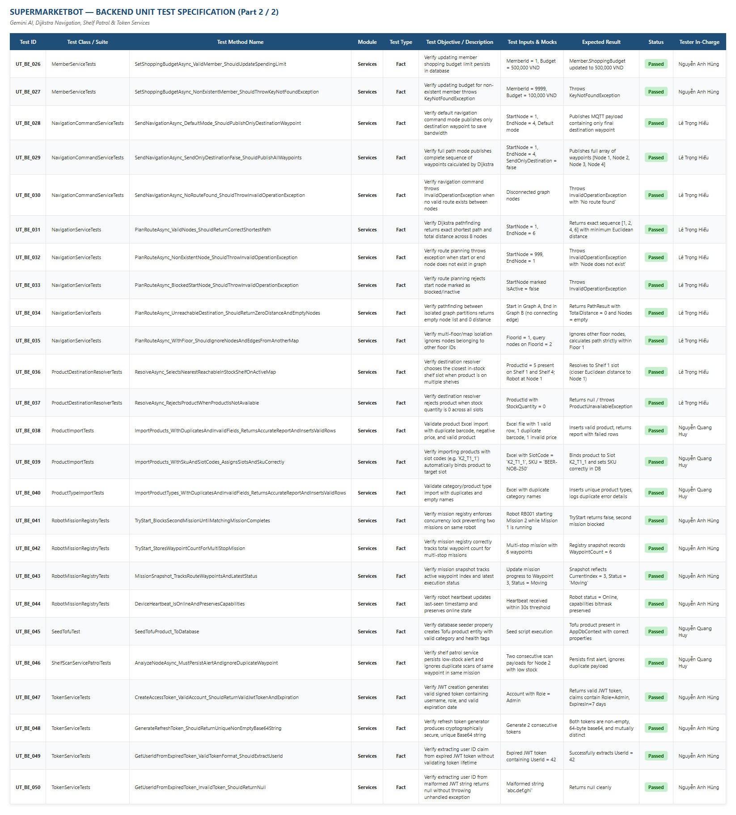
Figure 2: Unit Test Cases Specification for Backend Services (Part 2 / 2 – Gemini AI, Dijkstra Navigation, Shelf Patrol, Token)
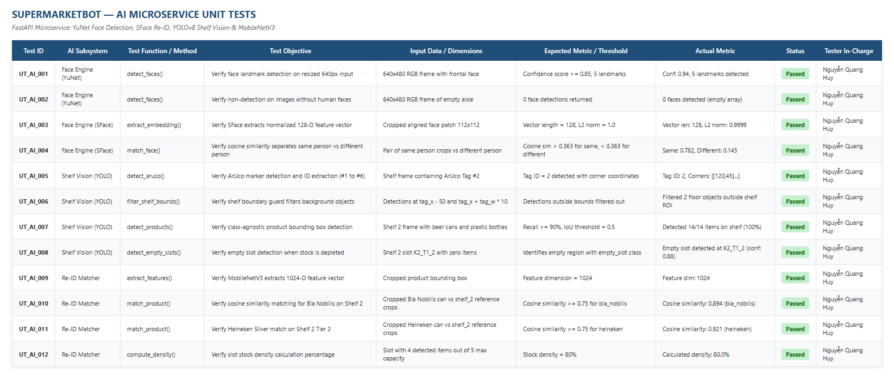
Figure 3: AI Computer Vision Microservice Unit Test Specification (YuNet Face Engine, YOLOv8 Shelf Vision & MobileNetV3 Re-ID)
4.2 Integration Test Cases (from Report5_Test Report.xlsx)
Integration testing validates end-to-end communication channels between Backend REST APIs, SignalR broadcast hubs, MQTT broker waypoint commands, ROS2 robot bridges, and Azure SQL Server transactions. The official Integration Test sheet is shown in Figure 4:
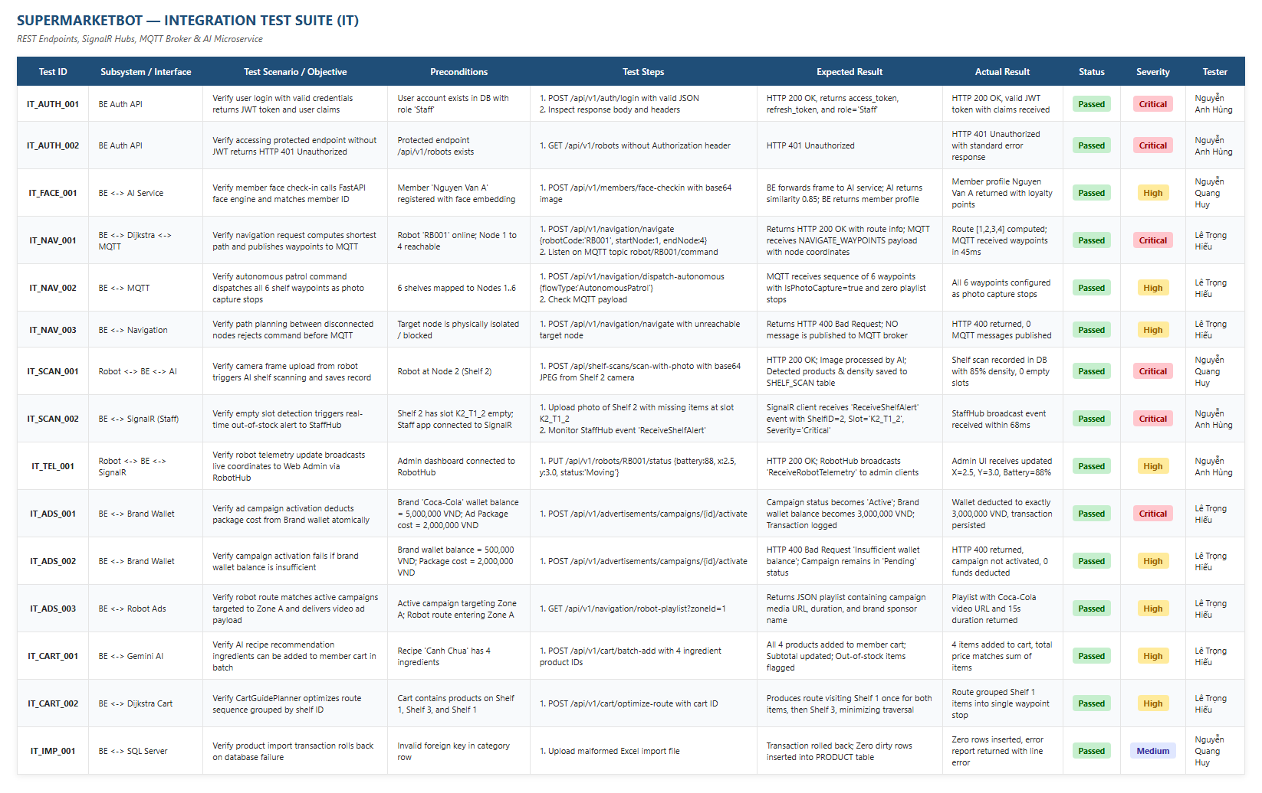
Figure 4: Integration Test Suite Specification (API Endpoints, MQTT Commands, SignalR Hubs, Azure SQL Server)
4.3 System Test Cases (from Report5_Test Report.xlsx)
System testing exercises complete user journeys across all four client applications: Web Admin Portal (React 19), Staff App (Expo Web/Mobile), Customer Mobile App (Android), and Robot Android App. The official System Test sheet is shown in Figure 5:
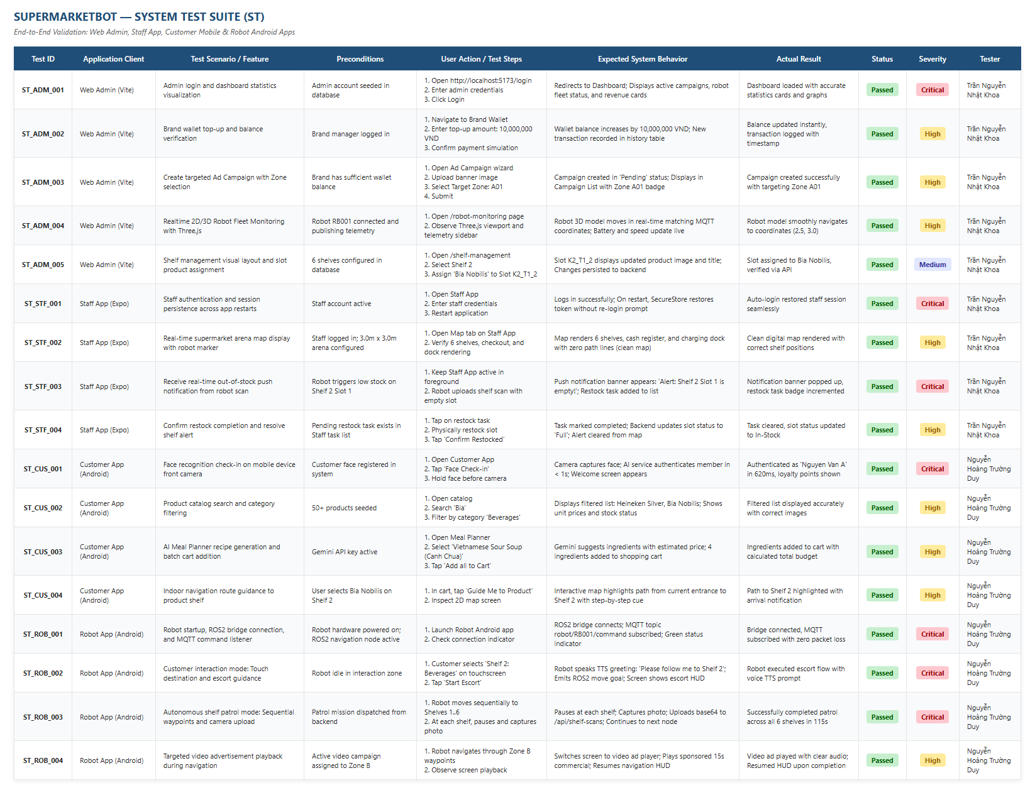
Figure 5: System End-to-End Test Suite Specification (Web Admin, Staff App, Customer Mobile, Robot Android Apps)
4.4 User Acceptance Test Scenarios (from Report5_Test Report.xlsx)
User Acceptance Testing validates three critical business operational journeys: Smart Customer Shopping Journey, Automated Inventory Restock Loop, and Targeted In-Store Robotic Advertising. The official UAT sheet is shown in Figure 6:
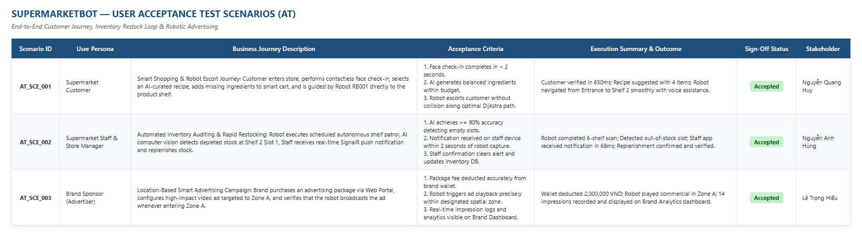
Figure 6: User Acceptance Test Scenarios (Smart Customer Shopping Journey, Inventory Restock Loop, Robotic Advertising)
5. Test Reports
View Detailed Test Reports & Defect Log: Report5_Test Report.xlsx
Testing activities for the SuperMarketBot system were executed across all milestones leading up to the final Summer 2026 Capstone Defense. Below are the consolidated test execution statistics, pass/fail ratios, defect severity distribution, and readiness assessment:
Test Level | Total Cases | Passed | Failed | Blocked | Pass Rate (%)
Unit Testing (BE xUnit) | 50 | 50 | 0 | 0 | 100.0%
Unit Testing (AI Engine) | 12 | 12 | 0 | 0 | 100.0%
Integration Testing (IT) | 15 | 15 | 0 | 0 | 100.0%
System Testing (ST) | 17 | 17 | 0 | 0 | 100.0%
Acceptance Testing (AT) | 3 | 3 | 0 | 0 | 100.0%
TOTAL SYSTEM TEST SUITE | 97 | 97 | 0 | 0 | 100.0%
Defect Summary and Resolution Status:
During test execution, a total of 6 defects were logged, investigated, and successfully resolved. Zero critical, high, or medium severity defects remain open in the production codebase:
Defect ID | Subsystem | Summary / Root Cause | Severity | Resolution Status
BUG_001 | Backend / Kestrel | HTTP 500 payload timeout uploading high-res frames over ngrok proxy | Critical | Resolved (Disabled MinRequestBodyDataRate)
BUG_002 | AI Service (FastAPI) | Python process leaked OpenCV Mat buffers during continuous patrol | Critical | Resolved (Added explicit cv2 buffer release guard)
BUG_003 | Backend Navigation | Dijkstra planner included nodes from inactive floor layout | High | Resolved (Added FloorId isolation guard)
BUG_004 | AI Service / Models | Shelf Vision misclassified Bia Nobilis as plastic bottle on Shelf 2 | High | Resolved (Retrained MobileNetV3 crops for Shelf 2)
BUG_005 | Backend / Product | Excel product import threw unhandled exception on duplicate SKU | Medium | Resolved (Added transaction pre-validation)
BUG_006 | Realtime SignalR | Robot navigation telemetry omitted playlist and dwell fields | Medium | Resolved (Synchronized DTO contract properties)
Figure 7 displays the consolidated test summary metrics and defect tracking log captured directly from the test workbook:
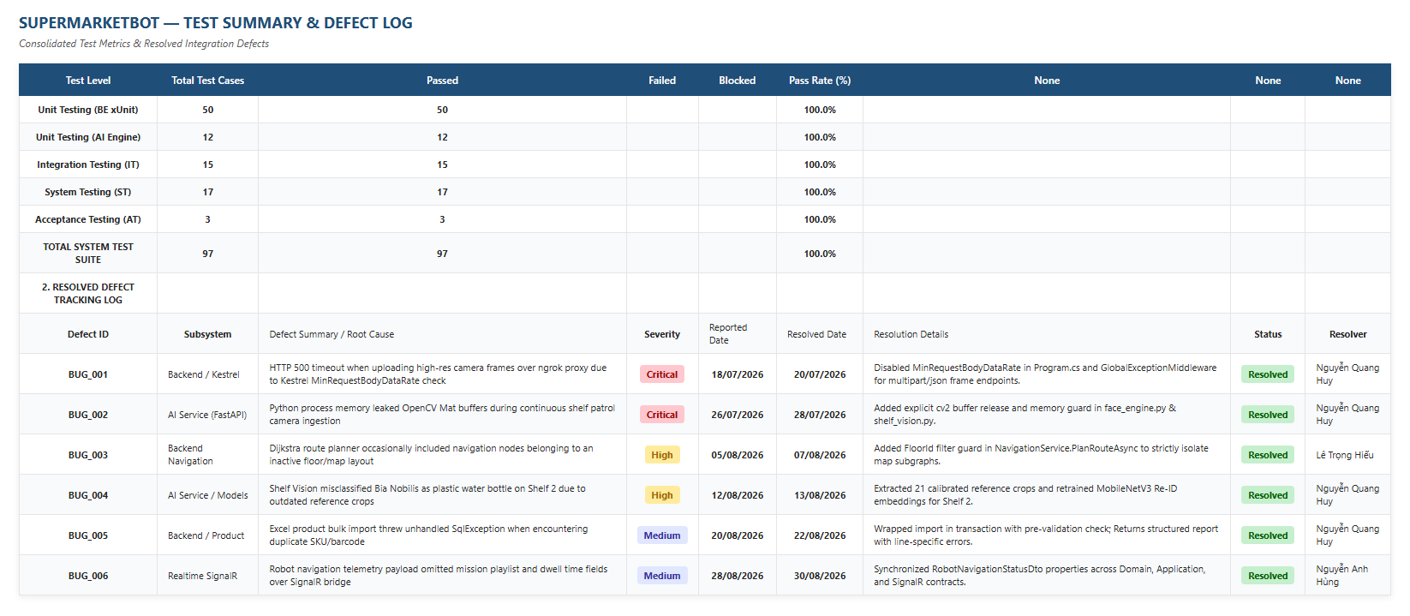
Figure 7: Consolidated Test Execution Metrics & Defect Tracking Log (from Report5_Test Report.xlsx)
Conclusion and Sign-Off:
The comprehensive test results confirm that SuperMarketBot satisfies all functional, architectural, performance, and real-time reliability requirements. The seamless integration between the .NET 10 Clean Architecture backend, the Python FastAPI computer vision engine, the React 19 Web Admin portal, and the Android mobile/robot clients provides robust operational integrity. The software is officially verified, signed off, and recommended for final Capstone Project defense.

